Table of contents

ETR 2005-01

LHCb
VELO wakefield suppressor
RF measurements

March 2005

Project no: 39300

F. B. Kroes

e-mail: frans@nikhef.nl

Abstract:

The VELO tank consists of 2 movable detector boxes. During the LHC beam injection cycle the beam stay clear distance is about 5.5 cm. During the experiment the detecor boxes are closed with a resulting beam channel of 12mm diameter.
The beam traverses this VELO detector. Any discontinuity in the beam channel causes building up of wake fields which partly dissipates in the surrounding beam channel.
A mockup tank with a similar detecor box configuration is build to measure these losses.
The beam is simulated by a RF signal through a wire in the center of the channel. The measurements concentrate around the mechanical connection design between the standard beam channel pipe and the movable detector boxes named Wakefield Suppressor.

- Introduction 3
- Reference 5
- RF relating problems around the LHC-B detector. 23 febr.2000 6
- RF measurement of the coupling impedance and the RF modes
in the LHC-B vertex chamber. 21 march 2000 8
- Measurement room for the prototype LHC-b vertex chamber 10
- RF coupling impedance measurements in 2001 11
- RF coupling impedance measurements in 2002 13
- RF coupling impedance measurements in 2003 15
- Resistance measurement of wake field suppressor contact on the
Detector box 18
- Measurements Readmefirst files a through t 19-38

CD
- ET report “LHCb VELO wakefield suppressor RF measurements
-All measurements a through t
-Presentations
-Details

Introduction.

For this project a mock-up tank is build to simulate the mechanical set up of the movable detector boxes in the Vertex vacuum chamber. A RF signal which content has the same frequency spectrum as the beam in the design report, travels through a wire in the center of the Vertex tank.
Measurements are done in frequency domain because two network analysers of Hewlett Packerd were present.
The first one The 8720 with which we started the measurements has a lowest frequency of 130MHz. Measurements are done from 150MHz to 1.5 GHz.
Later on it became important to see the behaviour at a lower frequency. We decided to send the older HP8753 NWA to Agilent Technologies for calibration.
Measurements are made for the S21 of the Device under test (S21.dut) and the S21 of the Reference pipe (S21ref).
S21 is the forward transmission parameter of the scattering parameters and stands for the square root of the power transmitted from port 1 to port 2.
In the power-point presentation files fk20011206 and fk20021216R details are presented of the frequency spectrum of the beam-current components and the measured transmission parameter S21 and how to calculate the coupling impedance of the vertex set-up.
The coupling impedance at a certain frequency multiplied by the quadrature of the beam-current component at that frequency gives the power dissipation at that specific frequency.
The best result should be a coupling impedance of 0 Ohm over the whole frequency range.
The dissipation in the vertex chamber are then exactly the same as the losses in the ref. pipe which is a nice Aluminium beam channel of 54 mm diameter in our case. This means not more then the ohmic losses introduced by the image currents in the wall.
If there are discontinuities in the beam channel it will give peaks at a certain frequency and the coupling impedance grows. If this higher coupling impedance matches a beam current component of the beam spectrum the dissipation will grow.

The measurements are given in the directory “all measurements” and the first measurement is “a” and the last measurement is “t”.
The details of each measurement is given in a “readmefirst file” in the same directory.
Measurement “a” starts with the empty tank.
In each following measurement the mechanical set up grows to its definite mechanical layout given in measurement “o”.
The measurements from “p” to “t” are in principle the same set up as “o” but there is some experimentation with foil strips to see what happens with the coupling impedance peaks.
Each Measurement folder contains the frequency measurement lists, extracted from, the Network analyzer as “excel” files or “text” files.
If there are pictures of the layout of that particular special set up they are in the same folder.
In each set up 4 different detector box distances are measured,
Distance 2mm, This is in our set up the minimum distance and the experimental ideal situation.
Distance 20mm, distance 40mm and distance 60mm.
During beam fill time the max. distance of 60mm will be chosen for the beam stay clear situation.
In the beginning period of the experiments it is to imagine that the minimum distance cannot be obtained because of the machine parameters at that moment.
Because of the fact that the coupling impedance is very small for all the distances there is no limit for the experimental set up based on dissipation reasons.
The beam coupled impedance is as small as possible in the 40 to 60mm condition because then the transmission line impedance is very close to the beam pipe impedance of 55mm diameter.

In the measurements of the Aluminium tank in the definite situation which means measurement “o” there is still a resonance peak at about 900MHz with an impedance of 100 to 150 Ohm.
Later on in the situation with the Stainless steel tank this peak will be reduced to nearly 0 ohm because the Q of this resonance will be much lower in the stainless steel case.

Reference:

-On coaxial wire measurements of the longitudinal impedance.
H.Hahn, F. Pedersen, BNL 50870, UC-28

-Die Hochfrequenz-Abschirmung des HERA-B Vertex detectors, F. Klefenz
Internal Report DESY M98-01 Januari 1998

-Measurement of modes in the HERA-B vertex chamber excited by the HERA proton beam,
R.Wanzenberg, M. Wendt, DESY, Hamburg

-Measurement of the longitudinal coupling inpedance of the HERA-B vertex detector chamber, F. Gallucio, M.R. Masullo, V.G. Vaccaro, B. Schwingenheuer, F. Klefenz, R. Wanzenberg, M.Wendt.

-Power loss in enlarged experimental chambers of the LHC, L. Vos
LHC project note 262, juni 2001

-Coupling impedance measurements: an improved wire methode.
V.G. vaccaro, IFTN/TC-94/023, 14 nov 1994

-Measurement of coupling impedance of accelerator devices with the wire-methode.
J.G. Wang, S.Y. Zhang, Nucl.Instr.&Meth.in Phys.Res. A 459 (2001) 381-389

-The silicon vertex detector for LHCb: interaction with the LHC beams and design of a radiation hard front end chip, N. van Bakel, Thesis, Free University Amsterdam

RF relating problems around the LHC-b vertex detector 000223/F.Kroes

It is well known that a moving bunched beam emits a EM field which will induce currents in the wall of the beamchannel. In places where parts of a detector are situated this beamchannel is a part of a bigger tank with open connection to other spaces which can form cavities.
Under influence of the beam all possible resonance frequencies which can exist in the formed cavity structure and which matches to the frequency content of the beam will grow in amplitude. (Wakefields)
A part of the beam energy will be lost to these resonating modes.
These RF modes have transversal and longitudinal EM fieldcomponents which can disturb the dynamic behaviour of the beam which can lead to beaminstabilities. It is important that the amount of resonating modes in the final design is at a minimum and that the quality factors are low.

What is important in the design of the LHC-b vertex detector with respect to RF wakefields?
The beampipe should have no discontinuities and must be as flat as possible. The image currents in the beampipe wall are in the longitudinal direction parallel to the beam. Each distorsion of this current generates unwanted EM fields. An increase or decrease in beamchannel diameter gives a wallcurrent component square to the beam and should as small as possible by making the cross section changes as slow as possible (long tapers). A real interupted beamchannel cannot be allowed.

Which actions are important in relation to this LHC-b vertext design from the RF viewpoint?.

- Shielding of the silicon strips and electronics.
The silicon strips including its electronics are positioned close to the Aluminum beamchannel screen and must not interact with the EM fields of the bunched beam. The resulting EM fields at the silicon strip side should be as low as possible. We take into account a maximum level of 1V/m close to Aluminum surface for the 40MHz frequency component in relation to the bunch spacing of 25 ns. Because of the skineffect the noise level for the higher frequency components will decrease. From the physic point of view the material between the beam and the silicon strips should be as thin as possible and can be a point of conflict. So it is very important that a decision will be to the satisfaction of both diciplines. The Aluminum screen between the beam and the silicon strips is only one surface of a totally closed metal box around the total electronics part including cables and must be seen as Farady Cage. In the space around this faraday cage there are resonating fields driven by the beam. Because of the fact that the box is part of the beampipe it is important that the electronics part is isolated from the cage and has its own reference.

- Modelling of the beamchannel inside of the Vertex tank
The mechanical beamchannel and other dimensions should be chosen in a way that the amount of energy lost by the beam to resonating modes is as low as possible. This means that the shuntimpedance (Rs) of the resonating modes are as low as possible. This shuntimpedance normally is given as a normalized broadband impedance Z/n (n=the frequency of interest divided by the revolution frequency of the ring). The maximum broadband impedance which is allowed will be specified by the machine physisists of the LHC ring. The first step in the design is that all the frequency modes and losses can be calculated with the MAFIA computer program. The design must be modified if the calculation gives results that does not match the specified Z/n value. This process leads to an acceptable design on the basis of calculation.

- Measurement of the Z/n
It is possible to perform RF measurements to prove the calculated results. We are thinking of the following two types of measurements.
- Measurement of the longitudinal impedance of the design by means of a frequency network analyzer. In this setup the beampath will be simulated by a central wire through the detector tank from the input to the output. Then a RF transmission measurement with a networkanalyzer will be compared to the transmission measurement of a reference pipe. From these results the Z/n can be calculated.
To get a better inside in the resonance properties of the separate modes it is important to mount several inductive measrement loops in the prototype model. In this situation it is possible to measure the resonance frequencies and there corresponding Q's seperatly. For this reason we can mount a source and detection loop for two orthogonal directions (4 loops) in the model.

000321/F.Kroes
RF measurement of the coupling impedance and the RF modes in the LHC-b vertex chamber.

It is possible to perform following two types of RF measurements.
- Measurement of the longitudinal impedance of the design by means of a RF vector network analyzer. In this setup the beam-path will be simulated by a central wire through the detector chamber from the input to the output. Then a RF transmission measurement with a network analyzer will be compared to the transmission measurement of a reference pipe. From these results the Z/n can be calculated.
- To get a better inside in the resonance properties of the separate modes it is important to mount several inductive measurement loops in the prototype model. In this situation it is possible to measure the resonance frequencies and there corresponding Q's separately. For this reason we can mount a source and detection loop for two orthogonal directions (2 loops) in the model.

To perform these measurements several actions are needed. I will give a list of activities
- Measurement location
Find a laboratory location where enough room is available for a prototype vertex chamber(1.8x1 m) with some measurement equipment around it. This location must be available for years! If the measurement setup is ready it will be standby and ready to use.
- Design and manufacturing of a prototype vertex chamber for the above mentioned measurements
The most easiest way is to fabricate the chamber out of aluminum with the right diameter and length but without al the big holes. The inside configuration should be close to the real design.
There should be accessibility to the inside for changing mechanical details and the wake-field suppression part and to stretch a wire for the measurements. Discussion with the mechanical department will start as soon as possible.
- Manufacturing of a standard peace of LHC-B beam-pipe as a reference for the impedance measurements.
A standard LHC beam-pipe with the same length as the vertex chamber will be used for reference measurements.
- Design and manufacturing of the RF input and output matched tapers for the connection of the network-analyzer to the reference pipe and chamber
Network analyzers are working with a standard reference impedance of 50 ohm. By means of matched tapers or resistance matched flanges the 50 ohm system will be matched to the LHC beam-pipe reference which is around 300 ohm (cross section dimension related)
- RF measurement setup design and RF equipment testing.
The network analyzers (HP8520B or 8753A) should be checked if they are in good condition. For data acquisition and impedance calculation a pc computer with the HP interface bus can be used.
- Real RF measurements.

Impedance
The target is to shape the beam-channel in such a way that the wake-field generation by the bunched beam will be below an acceptable level.
It is important that in an early state already RF impedance measurements can be done to a vertex chamber filled with the original parts like, detector boxes, frames, wake-field tapers, strips etc.
The measurement procedure is to do a measurement after each change of the inside configuration by strips, wires, connections and to compare these measurements with the measurement before the modification. A compare of the measured results with the calculated data from the MAFIA program is needed because the impedance level or scattering parameter amplitude S12 is comparable.
The absolute frequencies are shifted because of the influence of the stretched wire.
Resonance Modes
By means of two orthogonal loops it is possible to measure all the resonance frequencies of the vertex chamber including its content. For this measurement there is no wire in the chamber and the real frequencies with there Q's can be measured. The dangerous high Q frequencies can be influenced by modifications to the inside and the results can be measured afterwards.

Meetruimte voor prototype LHC-B vertex tank 000912/F.Kroes

Op het NIKHEF wordt binnen de LHC-B collaborate de Vertex detector ontwikkeld.
Dit is een ronde tank van ongeveer 2 meter lang met een diameter van 1 meter.
In deze tank komen de silicium detectoren die voor de bepaling van de baanreconstructie nodig zijn. Inwendig wordt dit een complexe constructie vanwege de physische-, vacuum-, mechanische-, elektronische- en RF(hoogfrequent) eisen waaraan het definitieve ontwerp zal moeten voldoen.
De bundel kan in zo'n grote ruimte allerlei trillingsmodi aanslaan die op hun beurt weer verantwoordelijk zijn voor,

- Te heet worden van onderdelen binnen de tank.
- Stoorvelden op plaatsen waar dat niet mag.
- Beinvloeding van de bundel zodat instabiliteiten ontstaan.
- etc.

Met de RF metingen kan niet vroeg genoeg begonnen worden, daarom wordt er nu een eenvoudig meetmodel geconstrueerd dat aan de binnenkant natuurgetrouw volgens het ontwerp wordt opgebouwd met een tweeledig doel,
-Meten van alle relevant RF (hoogfrequent) parameters en dus opbouw van de benodigde RF meetopstelling.
-jgen in de mechanische constructie door plaatsing van de prototype deelconstructies in de tank zodat mechanische- en onderlinge interferentie problemen vroeg worden gesignaleerd.

Benodigde meetruimte ongeveer 4x5 meter met de standaard laboratorium infrastructuur voor de duur van een aantal jaren.
In deze ruimte staat de prototype meettank met daaromheen loopruimte van 1-1.5 meter. Met er dicht op de meetopstelling met RF networkanalyzer en andere aanverwante RF meetapparatuur. Plaats voor een PC met netwerkaansluiting.

RF coupling impedance measurements in 2001

LHC-b Vertex

Wire methode of measurement
To measure the longitudinal coupling impedance of the Vertex mechanical setup under realistic conditions a measurement tank (mockup tank) is constructed.
The inside of this measurement tank is build up according the latest design review in which al the parts like silicon boxes and bellows are simulated by Aluminum and Stainless steel parts.
The connection of the LHC standard beampipe of 54mm to the 12 mm inside dimension of the silicon boxes are the so called “Wakefield surpressors” (fig.) and are mounted at both sides of the boxes.
The measurement results for a “ideal situation” (beam path with right dimensions and the dimension changes by means of closed tapers, no coupling to the tank exist and the real part of the impedance is < 100 Ohm.
In reality the silicon boxes are movable from closed position to a maximum opening of 60mm which is desired for the beam injection cycle.
For the case with the wakefield surpressors mounted i.s.o. the tapers the measurement results are still < 100 Ohm for the silicon boxes closed or at a distance of 20mm of each other. By silicon box distances from 20 to 60 mm the opening in the wakefield surpressors give increase in RF coupling to the tank resonances and the real part of the coupling impedance is growing to 400 Ohm.
To minimize this RF coupling a modified wakefield surpressor will be constructed.

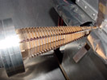

Silicon detector shielding by means of the RF foil
EM field penetration through the thin Aluminum shielding of the Silicon detecor boxes gives possible rise to the noise level of the output signal levels.
A measurement setup will be prepared.
A coaxial line of 50 Ohm is made of which the outer conductor is of Aluminum foil of which the thickness can be chosen. The power level in this coaxial line over the frequency band of interest, in our case with a max. limit to 150MHz, can be increased to 15 W max. In this way the EM field level at the outside of the foil can be controlled to the expected level introduced by the beam in the frequency domain.
At .5mm distance of the Aluminum foil a prototype silicon detector with beatle setup will be mounted.
The influence of the EM leak field on the noise level of the silicon detector readout will be measured.

LHCb vertex

RF coupling impedance measurements in 2002.

Simulation measurements in a vertex mockup tank with the wire method.

Because of the wish of the CERN RF experts the frequency measurement range is changed from 150MHz-1,5GHz to 300KHz-1,5GHz because of the importance of the impedance behavior in the lower frequency part of the band.
This was possible after calibration of another existent Network analyzer which was better suitable for this measurement range. The higher signal measurement levels give a lower noise level in the output results.
During beam fill time of the LHC the two silicon strip detector boxes of are set in open condition for the max. beam stay clear situation. (60 mm maximum distance).

Wakefield suppressor design 1 (fig.1)
During this beam fill cycle the RF coupling between the beam path area at the Wakefield suppressor position and the vertex tank volume is too big and introduces many unwanted resonance’s with a high coupling impedance with real part around 250 ohm in the 500 to 1000 MHz frequency range.

Wakefield suppressor design 2 (fig.2)
To reduce this RF coupling the Wakefield suppressor is extended with side flaps.
Measurements show that the coupling impedance for the open condition is improved to real part 150 ohm for a single resonance at about 800MHz.

There is still a rather low Q resonance at about 800 MHz which did not change in frequency but only in amplitude for detector box distance change from 2 to 60mm.This effect is not a big problem but some time will be spent to discover the cause of this resonance.

In longitudinal direction both silicon detector boxes are connected by a very thin stainless steel connection screen at both sides.
During a measurement cycle this screen is removed in steps to measure its influence. The measurement results of both conditions, screen mounted or removed, are comparable.
We decide to go on without a longitudinal connection screen. (fig.3).

The coming period the setup in the mockup tank will be changed. The detector boxes will be covered with the realistic corrugated RF foil and the Wakefield suppressors are modified a little bit for less material content.

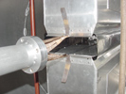 fig.1 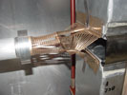 fig.2 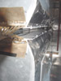 fig.3

Silicon detector shielding by means of RF foil

We simulate the beam in the frequency domain by a coaxial RF power line at 50 ohm.
The outer conductor of the coax is 30 micron Aluminum.
The signal level in the coax was 10W CW at 40MHz.
At 5mm from the coaxial outer conductor the prototype silicon strip detector is mounted.
This strip detector is illuminated by the magnetic leak field from the coax power line.
Magnetic field level at this position is about .7 A/m, Which give an Electric field level of
1 V/m for the impedance of 1.5 ohm at this point.
These leakage field levels are a factor of 1000 higher than in the real situation.
As a second step we made a hole in the aluminum outside conductor just in front of the silicon strip detector which gives much higher EM field levels.
In both situations we do not see influence on the working of the silicon in combination with the electronics of the test setup. There was no change in noise level background.

Next tests will concentrate on the frequency spectrum in the KHz band of the beam which are related to the circumference of LHC.

Pictures of the test setup
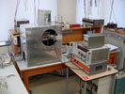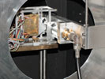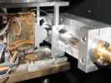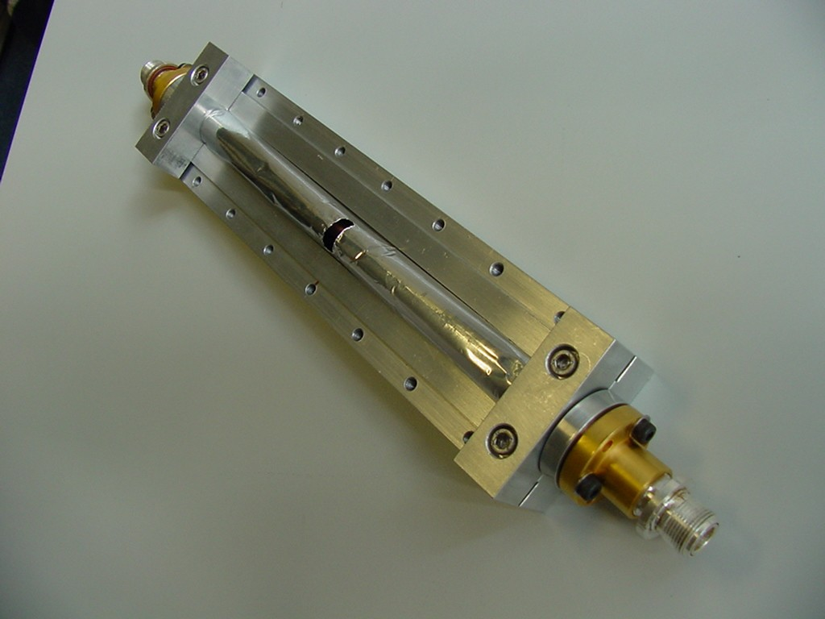

LHC-b vertex

RF impedance measurements in 2003

Simulation measurements for the wake field suppressor design with the wire method
During 2003 the setup in the mockup tank is modified. The present setup consists of,
- The detector box surfaces facing to the beam are now covered with the definitive pressed corrugated RF Aluminum foil of 300 micrometer.
- The Wakefield suppressor at the front side of the detector boxes is better shaped for the direction of the image currents in the open situation to 60mm max. during beam fill time.
- The Wakefield suppressor at the exit foil side is still the type with the side-flap because it must fit in the mechanical exit foil construction at the beam center.
Pictures 1 and 2 show the details of the front- and backside Wakefield suppressor and the corrugated Aluminum foil.
The measurements gave good results for all the measured distances of the detector boxes 20, 40 and 60 mm.
In fig 3 the measurement results are given for the detector box distance of 60mm with the described setup. The Real and Imaginary coupling impedance are shown.
The earlier 850 Mc and now 900Mc resonance is still present but is smaller then in the former measurement setup during 2002. This resonance is a complicate RF mode of which the mockup tank is part of the resonator. Because of the fact that the conductivity of the RF corrugated foil is 1/3 of the conductivity of pure Aluminum the Q of this mode is lower in the present setup.
The material of the tank in the realistic design is of stainless steel, which will again decrease the effective Q of this unwanted resonance.
The topics for 2004 are,
- Small modifications of the wake field suppressor designs only for better mechanical behavior during detector box movement to 60 mm distance.
- Measurement of the DC contact properties between the CuBe Wakefield suppressor and the Aluminum detector box for different contact platings.

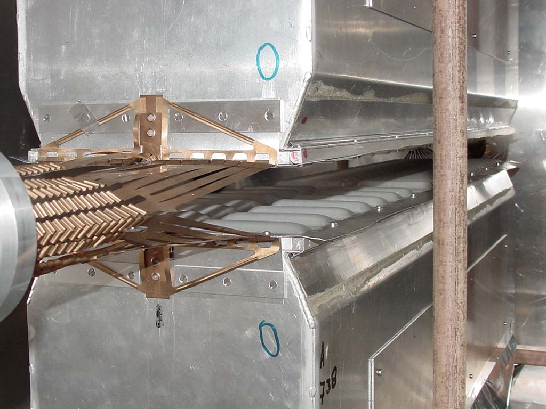
Fig. 1

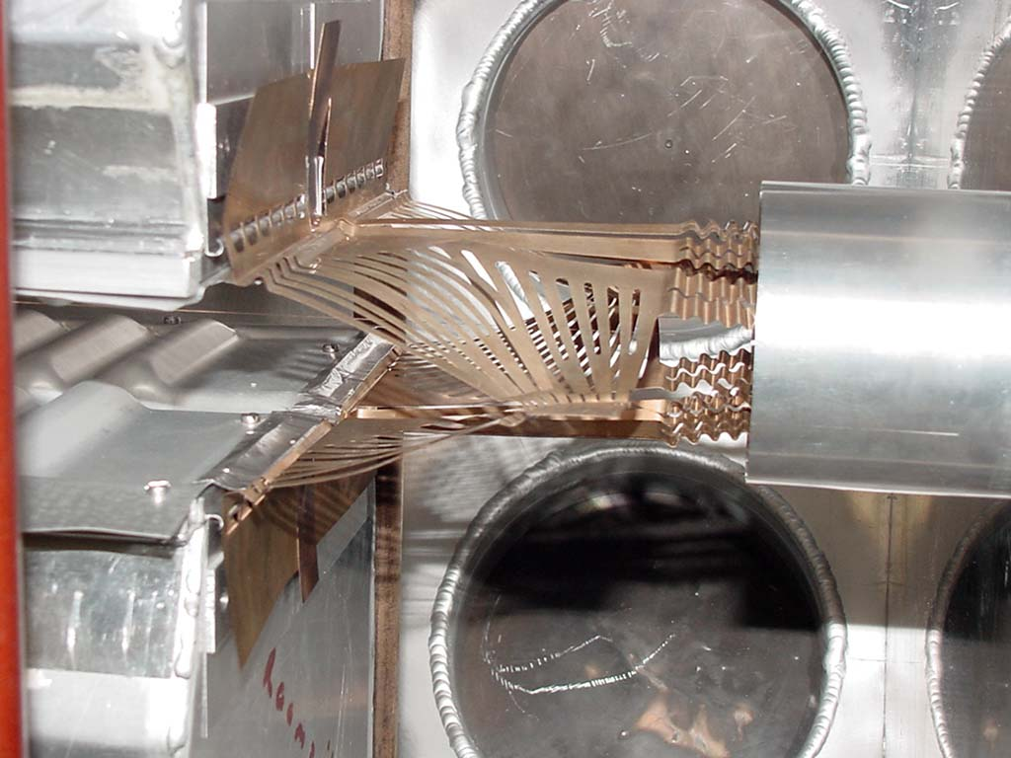
Fig.2

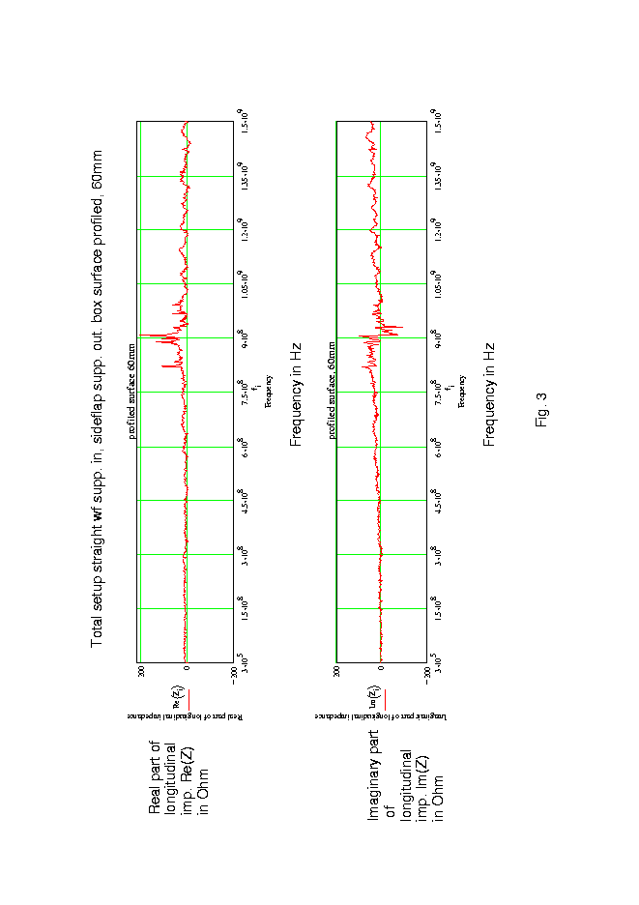

Resistance measurement of wake field suppressor contact on the detector box

Each wake field suppressor halve has a central connection on the detector box and a total of ten contacts along the broadness of the detector box.
A measurement is done to get an idea of the resistance for DC for each contact type.
The contact surfaces are gold plated.

The central contact (12mm connection), 1 per half wake field suppressor.
This contact is measured with a separate part with a DC bridge from ESI (Electro-Scientific industries) model 300:

Measurement result: 1- 1,89 mOhm
2- 2,17 mOhm
3- 1,79 mOhm average 1,904 mOhm
4- 1,79 mOhm
5- 1,88 mOhm
For the total wake field suppressor centre contact this means 1,904/2 = < 0,952 mOhm

A side contact, 10 per half wake field suppressor.

Measurement result: 1- 1,50 mOhm
2- 1,98 mOhm
3- 1,51 mOhm average 1,632 mOhm
4- 1,43 mOhm
5- 1,74 mOhm
For the total wake field suppressor side contacts this means 1,632/20 = 0,08 mOhm.

The contact resistances are very low because of the gold plating and should not give any problems in the definite situation with the expected beam image currents.

Coupling impedance measurements,

a-Empty mock up tank measurement

The measurement is made with the empty tank without any detector part mounted.
This means that the beam will generate all the resonance frequencies modes which can exist and which are coupled to the wire. The frequencies are shifted from there exact frequency because the wire is shortcutting the E-fields in the center of the tank.
The picture will show all the possible frequency modes which can be effected by the beam.
A lot of energy will be taken from the beam to feed these resonance’s.
If the frequency component in the beam frequency spectrum matches a frequency mode in the tank and has some coupling to the beam it will rise in energy.

The measurements are done in 1601 point in the frequency band of 170MHz to 1,5 GHz
The frequency files are divided in imaginary and realistic files for reference (ref) and device under test files (dut). Measurements are done with HP8720 network analyzer.

The text files are the measurement results for all the S parameters measured.

Pictures of the tank and measurement setup are in the JPG files.
Measurement results are in the file “long.imp.empty.tank.pdf”

Resonance frequency measurement with the four loops in the hor. and vert. polarization direction.

All the frequencies are measured. There is a measurement with the wire inside the tank and one measurement without the wire. In the wire present case the frequency amplitude can be shifted and can be lower in amplitude because of the detuning and damping.

b-Closed conductor measurement

Wire method
This measurement is made to simulate the best possible situation for the surrounding of the traveling beam through the vertex detector.
The beam path start with a standard beam pipe diameter of 55 mm and changes by means of a taper to 12 mm diameter through the detector boxes in closed situation and changes back to 55 mm via a taper. The channel is from solid Aluminum according the sketch below.
.

Channel diameter 55mm 12mm 55mm 65,5cm 6cm 112cm 10cm

- Measurement at 15 may 2001 for the frequency range 150MHz to 1,5 GHz in 1601 points with network analyzer HP8720. This measurement is done in the mockup tank. The frequency lists in excel are separate for the real and the imaginary part
- Measurement at 2 December 2002 for the frequency range 300KHz to 1,5 GHz in 801 points with network analyzer HP8753. This measurement is done with a separate setup. The frequency list in excel is a combined one. The first number is the real part and the second number is the imaginary part of the first measurement point etc. for the rest.
The results are similar and there are no effects in the low frequency part of the measurement.

Loop measurement

The setup in the first measurement “the closed conductor setup in the mockup tank” is used to measure all the resonance frequencies in the Mockup tank. The closed conductor path is the inside conductor for this coaxial cavity.

c-Measurement of the prototype wake field suppressor

This measurement is the same setup as the “closed conductor measurement” in the Mockup tank. The second taper from the right side is removed and the prototype wake field suppressor is mounted. Look at the pictures in this directory.

The resultant measurement differs not much from the “closed conductor measurement”.

Measurement is done in 1601 steps in the frequency range 150MHz to 1,5GHz with HP8720 network analyzer.

The frequency files are divided in imaginary and realistic files for reference (ref) and device under test files (dut). Measurements are done with HP8720 network analyzer.

The text files are the measurement results for all the S parameters measured.

d-Measurement of the prototype Wake field suppressor with bad contact.

To demonstrate the influence of a very bad contact of one side of a wake field suppressor we have mounted a thin piece of Teflon in the small diameter connection side of the prototype wake field suppressor.

The measurement is done in 401 points in the frequency range from 130MHz to 300MHz because in this part a resonance exist at about 150MHz.

In this directory you find the measurement for the good contact situation and the measurement for the isolated situation.

e-Measurement of the closed conductor set up where the second taper or prototype wake field suppressor is not in place

In this situation there is an interruption in the closed conductor path in the Mockup tank.

The beam which travels through the closed conductor path couples to the beam in this interrupted area and generates all type of resonance’s.

This measurement shows that any interruption in the beam current conduction path has a big influence on the beam coupled impedance and is not allowed.
The outside conductor is the mockup tank.

55mm diam. 12mm diam Taper out

65,5cm 6cm 112cm 10cm

The measurement is in the frequency range of 150MHz to 1,5 GHz in 1601 steps.
The measurement lists are split up in real and imaginary.
The text files gives all the measurement scattering parameter list.

The pictures give the situation of the wake field suppressor in place and removed.

In this situation (wake field suppressor out) again two loop measurements are done.
Measurement 6 with the wire in place and measurement 7 without the wire.

f-Total setup with detector boxes mounted and prototype wake field suppressors at both sides.

See picture “overview.60mm”

In the mockup tank the two detector boxes are mounted. Both sides are connected to the 55 mm beam pipe with the prototype wake field suppressor. In this starting total setup there are thin stainless steel connection foils between the detector boxes to shield the beam path area to minimize the coupling to the bigger mockup tank. In this measurement setup there are no bellows between the detector boxes and the inside surface of the mockup tank.

The measurements are performed for 4 distances of the detector boxes.

“Closed” is 2mm distance. The other distances are 20mm, 40mm and 60mm.

During the filling time of the ring the detector box distance will be 60 mm to meet the beam stay clear condition.

The measurements are done in the frequency range of 150MHz to 1,5GHz in 1601 points.

The real and imaginary lists are separate for the (ref) and (dut) measurements.

In the 60mm situation there are done two measurements,

One with the tank closed and one with the tank still open.

In the measurement result it is to see “in the tank open case” that the energy is radiated to the outside and there are lesser resonance ‘s with lower Q.

g-Total setup with detector boxes mounted and prototype wake field suppressors at both sides and detector box bellows in place.

See picture “bellows1 and bellows2”

Total setup measurement with the prototype wake field suppressors at both sides of the detector boxes. Thin stainless steel connection foils are still present and the detector box bellows are simulated by Aluminum foil.
The wire measurement is again done for the 4 positions,
- closed is 2mm
- 20mm
- 40mm
- 60mm
The frequency range of the measurement is from 150MHz to 1,5GHz in 801 points with HP8720 network analyzer.
The measurement lists are separate in real and imaginary data for the (ref) and (dut) cases. The lists are presented in text file too.

The text file of the complete S parameter is also present

For comparison we add an extra measurement for this 60mm situation. Around the big openings of the two prototype wake field suppressors pieces of Aluminium foil is placed to close the big openings. See pictures “foil.around.wakef.suppr.in.60mm” and “foil.around.wakef.suppr.out.60mm” in measurement “h” but the front connection foils between the detector boxes are here still present.
This measurement is found in the directory “60mm+foil”

It is immediately to see that closing of the openings with foil most of the resonance peaks are disappeared due to lesser coupling to the mock up tank.

h-This setup is the total setup as in measurement g-. but the thin stainless steel in- and output detector box front connection foils are removed.

See pictures “no.in.foil.60mm” and “no.out.foil.60mm”.
Measurements are done for 4 distances,
-2mm is closed
-20mm
-40mm
-60mm
It is already to see in these pictures that in this 60mm position there is a big coupling of the beam path with the rest of the mockup tank.
That’s why a lot of peaks are visible in the impedance measurement.

The frequency range of the measurement is from 150MHz to 1,5GHz in 800 steps with HP8720 network analyzer.
The measurement lists are separate in real and imaginary data for the (ref) and (dut) cases. The lists are presented in text file too.

The text file of the complete S parameter set is also present
For comparison we add an extra measurement for this 60mm situation. Around the big openings of the two prototype wake field suppressors pieces of Aluminium foil is placed to close the big openings. See pictures “foil.around.wakef.suppr.in.60mm” and “foil.around.wakef.suppr.out.60mm”
This measurement is found in the directory “60mm+foil”

It is immediately to see that closing of the openings with foil most of the resonance peaks are disappeared due to lesser coupling to the mock up tank.

i-New type of side flap wake field suppressor mounted at the entrance of the detector boxes. The wake field suppressor at the output is still the older type.

In this setup the big opening in the 60mm position is closed by the side flap of this type of wake field suppressor.
See pictures “new.wakef.supp.60mm.2” and “new.wakef.supp.60mm.3” and
for closed situation see pictures “NewWakefieldsupp.1 ,2 and 3”.

At the output side of the detector boxes the prototype wake field suppressor is still present is still present. See picture “new.wakef.supp.60mm.3”.
The impedance measurement is done for 4 distances,
- 2mm is closed
- 20mm
- 40mm
- 60mm

The frequency range of the measurement is from 150MHz to 1,5GHz in 800 steps with HP8720 network analyzer.
The measurement lists are separate in real and imaginary data for the (ref) and (dut) cases. The lists are presented in text file too.

Because of the fact that the output wake field suppressor is still the prototype one with the big opening in 40 to 60mm situation we put Aluminium foil around this output suppressor.
This measurement is in directory “60mm+foil.suppr.outp”
See picture “foil.around.wakef.suppr.out.60mm”

In this impedance measurement we see less peaks in the results.

j-The new type of side flap wake field suppressor mounted at both sides of the detector boxes.

In this setup at both sides of the detector boxes there is the new side flap suppressor mounted. See pictures “sidefl.suppr.inp” and “sidefl.supp.outp”

The impedance measurement is done for 4 distances,

2mm is closed

20mm

40mm

60mm

The frequency range of the measurement is from 150MHz to 1,5GHz in 800 steps with HP8720 network analyzer.
The measurement lists are separate in real and imaginary data for the (ref) and (dut) cases. The lists are presented in text file too.

In the text file all the S parameter data is shown.

k-The new type of side flap wake field suppressor mounted at both sides of the detector boxes, measured starting from the lowest 300KHz frequency

In this setup at both sides of the detector boxes there is the new side flap suppressor mounted. See pictures “sidefl.suppr.inp” and “sidefl.supp.outp”

The impedance measurement is done for 4 distances,

2mm is closed

20mm

40mm

60mm

The measurement is done with network analyzer HP8753 of which the lowest frequency is limited to 300KHz. The question came up from CERN to see the behavior of the impedance for the part under 150MHz as done earlier.

The measurement was done from 300KHz to 1,5 GHz in 800 steps.
- The measurement lists are of the combined ones. The first number is the real part and the second number is the imaginary part of the first measurement point etc. for the rest.

l-The thin stainless steel connection foils at the side of the detector boxes are still present. The foil will be removed in steps.

In this setup the foils will be removed in steps of 15 cm starting at the 4 corners of the detector boxes at the beam side.
The first measurement is repeated ( measurement K) is directory “+total”
The 4 removing steps are –15cm, -30cm, -45cm “still 10cm connected” both sides, total removed directory “-total”
For each removing step 4 distances 2mm(=closed), 20mm, 40mm and 60mm is measured.
Pictures are shown “sidescreen-45cm” for the situation of “–45cm “. 45cm removed.
After examination of the results the conclusion is that there is nearly no difference in the results of “foil present” or “removed”.
The connection foil between the detector boxes is removed.

For the “+total” case which means the side foils are still totally present we made an extra measurement in the 2mm(=closed) case when the wire is not exactly in the center. In the closed situation the coupling impedance grows to 100 Ohm i.s.o. 50 Ohm in the case that the wire is exactly in the center.

The measurement was done from 300KHz to 1,5 GHz in 800 steps.
- The measurement lists are of the combined ones. The first number is the real part and the second number is the imaginary part of the first measurement point etc. for the rest.

m- In this measurement the side connection foil is removed. This measurement is the same as found in the former l- measurement in the directory “-total”.

The measurement is done for the 4 distances,

-2mm (=closed)

-20mm

-40mm

-60mm

The measurement was done from 300KHz to 1,5 GHz in 800 steps.
The measurement lists are of the combined ones. The first number is the real part and the second number is the imaginary part of the first measurement point etc. for the rest.

n-Now we have bend the side foils parallel to the beam. The effective broadness of the detector box surface seen by the beam will grow about 20%.

In the measurements before there is a resonance in the impedance curves at about 850MHz. One of the talks at CERN there come up an idea that this resonance can be determined by the broadness of the detector boxes.

To test this theory we introduce this measurement to see if the resonance will shift to a lower frequency.

The measurement is done for the distances of 20mm, 40mm and 60 mm.

The results can be compared by the former measurement to see if the frequency is shifted.

The conclusion is that this resonance is not influenced by the broadness of the detector boxes but that this mode is a result of the total setup in this mockup tank.

The measurement was done from 300KHz to 1,5 GHz in 800 steps.
The measurement lists are of the combined ones. The first number is the real part and the second number is the imaginary part of the first measurement point etc. for the rest.

o-Measurement with the profiled foil. At the input a straight wake field suppressor and at the output the side flap wake field suppressor.

See pictures “prof.surf.straight.wfsuppr.input” and“prof.surf.straight.wfsuppr.output”

At the input side of the detector boxes is enough room to place an optimized wake field suppressor ( optimized for the current direction induced by the beam).
At the output there is interference with the exit foil pipe diameter. Here fits exactly the side flap suppressor design.

The measurement was done from 300KHz to 1,5 GHz in 800 steps.
The measurement lists are of the combined ones. The first number is the real part and the second number is the imaginary part of the first measurement point etc. for the rest.

This setup is the definite setup. The resultant resonance at around 900 MHz is decreased in this case because of the fact that the specific resistance is slight higher for this deformed Aluminum material (3% Mg).

In the 60mm distance directory the curves for the coupling impedance are given for the 3 distances in one representation.

If this measurement should be done in a stainless steel tank then the coupling impedance which is about 200ohm at about 900MHz is hardly to see because of the low Q.

p- Measurement with the profiled foil. At the input a straight wake field suppressor and at the output the side flap wake field suppressor and two AL side foil strips of 2 cm.

See pictures “strips1cm.60mm1 to 4”, The strips are in reality 2cm wide during this measurement.
The strips will shortcut the electric fields in the longitudinal direction of the boxes in the opening and has effect on the resultant resonance.

This measurement is done to see the influence of some experimental AL foils to screen the points of possible coupling.

The measurement was done from 300KHz to 1,5 GHz in 800 steps.
The measurement lists are of the combined ones. The first number is the real part and the second number is the imaginary part of the first measurement point etc. for the rest.

Measurement is done for the distances 40mm and 60mm. 20mm not possible because of the foil broadness of 2 cm.

q- Measurement with the profiled foil. At the input a straight wake field suppressor and at the output the side flap wake field suppressor and two AL side foil strips of 1 cm broadness along the detector box openings

See pictures “strips1cm.60mm1 to 4”

The strips will shortcut the electric fields in the longitudinal direction of the boxes in the opening and has effect on the resultant resonance.

Measurement is done for the 3 distances: 20mm, 40mm and 60mm.

The measurement was done from 300KHz to 1,5 GHz in 800 steps.
The measurement lists are of the combined ones. The first number is the real part and the second number is the imaginary part of the first measurement point etc. for t

r- For this measurement there are two AL strips of 0,5 cm along the detector box openings and small closing strips extra in all the wake field suppressor openings.

See all pictures pictures” 5mm+2+2+3inp and outp”

The measurement was done from 130Mhz to 1,5 GHz in 800 steps.
The measurement lists are of the combined ones. The first number is the real part and the
second number is the imaginary part of the first measurement point etc. for the rest.

s- For this measurement there are small closing strips in all the wake field suppressor openings with connection strip on the detector box.

See all pictures pictures”3+3+3inp and outp”
This measurement is done to get a feeling of the coupling by means of the resulting openings in the wake field suppressors and the opening between the detector boxes.

The measurement is done for the distances 20mm, 40mm 60mm.

The measurement was done from 300KHz to 1,5 GHz in 800 steps.
The measurement lists are of the combined ones. The first number is the real part and the second number is the imaginary part of the first measurement point etc. for the rest.

The impedance plots are also given for 3 distances in one picture.

t- For this measurement the side openings of the wake field suppressors are closed by 3 strips on the wake field suppressor. There is a cord around the wake field suppressors to keep the strips in line and a piece of foil is mounted to simulate the exit foil.

See pictures” 3+3.conn.wfs.cord+exitfoil.inp.jpg” and“3+3.conn.wfs.cord+exitfoil.outp.jpg”

The next wake field suppressors have some connections to keep the strips nice in line.
This measurement is done only to see what the effects are of the small changes.

The conclusion is that the peak will increase a little bit closer to a situation that there is nearly one small peak left.

The measurement was done from 300KHz to 1,5 GHz in 800 steps.
The measurement lists are of the combined ones. The first number is the real part and the second number is the imaginary part of the first measurement point etc. for the rest.

